Astrology and Holistic Healing Workshop by @Mulema_Alchemy

Directions for pulling up your chart: Please pull up your chart here for free: https://www.astro.com/cgi/ade.cgi?ract=genchart.cgi&lang=e. Those who don’t want to make an account can use guest user settings to pull up the chart. After you enter in your birth info, like date, city, and time (exact birth time is very helpful for this workshop) you will be directed to a details/extended chart selection page. Please scroll down and click the plus sign next to “options for zodiac and houses” then scroll and pick whole. Some astrologers use the placidus and other house systems, if you have another house system preference feel free to choose that preference. I use whole sign for individual charts and equal house system for synastry/compatibility.

Sign Wordbank:

Aries ( Fire/Cardinal) : pioneering, authenticity identity, impulsive, action, leadership, soldier/defense, fast, spring, budding, child/baby, leadership, new beginning, war, explore, )

Taurus (earth/fixed): slow/patient, sensual/senses, cherishing possessions, money oriented/loves saving money, physical security, stubborn, food, blossom, architecture/build/landscaping, plant appreciation,transferable skill, physical pleasure, ownership

Gemini (air/mutable): curiosity, reading, eternal student, duality, transcendence, twins, objective, speaking, bookworm, duality, writing, neighbors/neighborhood, playful, basic facts, trickster, joke, jack of all, learning)

Cancer (water/cardinal) : Home, house, safety, womb,family, tears, ocean shore, mother, hold, emotional awareness, secretive, connection seeking

Leo (fixed/fire): the sun, attention seeking, lavish, elegance, confidence, warm, welcoming, courage, mirrors, generous, self centered, performing arts, outwardly passionate emotions, drama, regality, fun, children inner child

Virgo (mutable/earth): putting emotions in a file cabinet, logical, ir-rationalizing emotions, being so realistic that you are afraid to dream, critical, stressing over details, a need to be of service/improve things, a need for order, connections to herbs/health consciousness, connections to pets, mastery, overanalysis, recognition of separation/differences

Libra (cardinal/air): harmony seeking, balance, indecision,fashion or art sense, fear of confrontation, relationship oriented, justice/fairness seeking, reading, visual art, self conscious/appearance, flirty, transcending opposites, indecisive

Scorpio (fixed water): secretive, emotional depth and intensity, psychological exploration, occult gift, possessiveness, sex, death/transformation, slow to trust, investigator of the dark/finding hidden meanings, merging, vengeful, devotion

Sagittarius archer (mutable Fire): freedom, expansion, gluttony, luck, exaggeration, optimism,travel, foreign cultures or languages, preachy, mentor ship, motivational guru, wealth, dare devil/risk taker, humor, wise old man, warm

Capricorn (cardinal/earth): ambitious, pessimistic, skeptical, provider, craves legacy/something built to last, structure, discipline hard work, career/goal/achievement oriented, cold, manager/authoritative , emotional suppression, Mastery, will power, restriction

Aquarius( fixed air): intellectualizing emotions, cherishing Friend groups, orgs, clubs, and humanitarian/social justice causes causes, invention/innovation oriented, future thinking, outside the crowd, unpredictable, rebel, know it all, accumulating info, sci fi, internet, apps, tech, telepathic/hivemind, future minded/before your time

Pisces: Dreams, escapism, compassion, substance abuse, symbolism, music, non linear, feeling the weight of the world/collective humanity on your shoulders, empathic, savior/victim/martyr complex, divinity, communion with spirit,

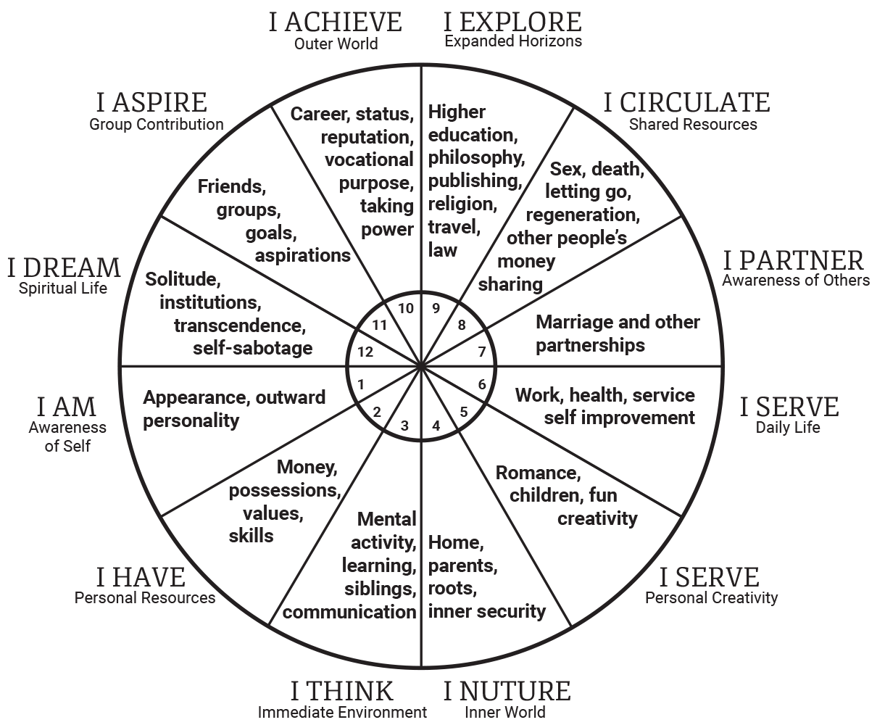

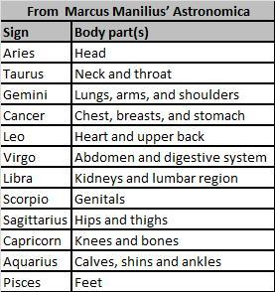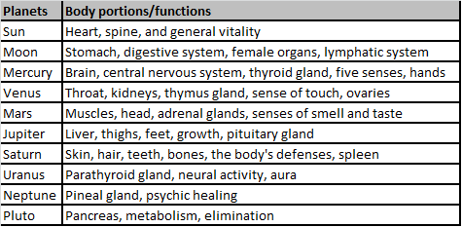

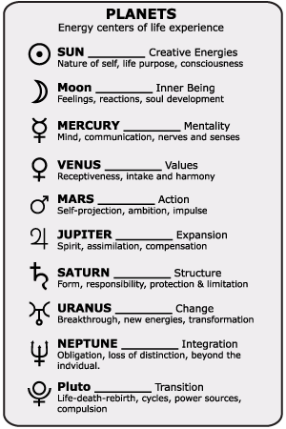

Some Astro Basics
The planet answers the question what (function), the sign is how (adjective/adverb in what style or way), the house is where/ environments/areas of life/themes. Whereas the planets are nature, the houses are nurture, the environments surrounding us situations in our lives that shape us. If you have a house that is empty of planets, that's ok, just record the sign in that house, we will talk more about this during the workshop.

Our moon is our emotional body. It’s how we emotionally respond to situations. Our moon shows what is natural to us, what’s intuitive and comes easily and innately. It contains a lot of our soul memory. The moon can also represent aspects of a mother figure in our lives. Knowing your moon sign can help you on your emotional exploration journey, and help you find emotional regulation tools that are right for you.

My moon sign is: My words for my moon are:

The fourth house shows our childhood, homelife, upbringing, family/roots/ancestry and what e need to feel at home
The sign in ruling my 4th house is:
In my fourth I have (planets/sign/rulerships)
My words for my fourth house sign is:

Our sixth house is of daily routines, work environment, how we are of service to others, our coworkers, and health/the physical body
The sign ruling my 6th house is:
My words for my fourth house is:

Our mercury describes how we learn new information, how we communicate, and our thought patterns.The third house deals with the environments and themes that help us retain/learn new information.
A word for my mercury sign is:
A word for my third house ruler sign in:
The planets in my third house are:

The 12th house deals with what is hidden from us but deeply indleng us subconsciously, it deals with self sabotage, escapist tendencies. But it also is a portal for our connection to spirit, spirit realms, our dreams , imagination, interconnectedness, and how we can surrender to the healing process and remember our wholeness.
A word for my 12th house sign is
Planets in/planet rulership of my 12th house are:

Mulemaalchemy.wordpress.com-- IG:Mulema_Alchemy--mulemalchemy@gmail.com

